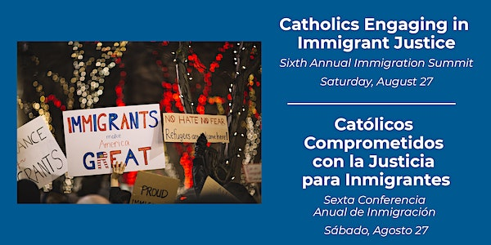

2022 Catholic Immigration Summit Resources
Morning Sessions

Session 1: Voices of Impacted Communities – Kati Ortiz
Latino Civic Alliance https://latinocivicalliance.org/about-us
Skagit Legal Aid https://www.skagitlegalaid.org/
Latinx Advisory Committee https://www.communityactionskagit.org/latinx-advisory-committee/
Session 2: Understanding and Supporting the Legal Needs of Immigrant Communities – Nicole Peger and Alissa Baier, Catholic Immigration Legal Services

Catholic Immigration Legal Services
https://ccsww.org/get-help/specialized-services/refugee-immigration-services/

To search for Department of Justice accredited organizations
https://www.justice.gov/eoir/recognized-organizations-and-accredited-representatives-roster-state-and-city

To search for non-profit immigration legal service providers
https://www.immigrationadvocates.org/nonprofit/legaldirectory/

To find private immigration attorneys that are American Immigration Lawyer Association (AILA) members https://ailalawyer.com/

Catholic Legal Immigration Network
https://cliniclegal.org/

National Immigration Law Center
https://www.nilc.org/

National Immigrant Justice Center
https://immigrantjustice.org/

Immigrant Legal Resource Center
https://www.ilrc.org/community-resources

United We Dream
https://unitedwedream.org/

Immigrants Rising
https://immigrantsrising.org/

Informed Immigrant
https://www.informedimmigrant.com/

To search for interpreters and translators
https://www.notisnet.org/
https://www.courts.wa.gov/programs_orgs/pos_interpret/

To learn more about notarios
https://stopnotariofraud.org/

Washington Immigrant Solidarity Network
https://www.waisn.org/

Northwest Immigrant Rights Project
https://nwirp.org/

One America
https://weareoneamerica.org/

Session 3 - Current Immigration Issues – Chris Koehler, Immigrant and Refugee Ministry, Archdiocese of Seattle and St. James Cathedral Immigrant Assistance
Justice for Immigrants – United States Conference of Catholic Bishops
Migration Policy Institute | migrationpolicy.org
The Center for Migration Studies of New York (CMS) (cmsny.org)
UNHCR - Emergencies

Afternoon Sessions
Session 1 – Catholic Advocacy – Mario Villanueva, State Catholic Conference
Washington State Catholic Conference (WSCC) Washington State Catholic Conference (wacatholics.org)
Join the WSCC network to receive emails https://www.wacatholics.org/be-an-advocate/join-our-network
WSCC 2022 Legislative Priorities https://www.wacatholics.org/stay-informed/wscc-2021-legislative-priorities Visit the site again in 2023 for updates for the new legislative session.
Justice for Immigrants, USCCB Justice for Immigrants – United States Conference of Catholic Bishops
US Conference of Catholic Bishops United States Conference of Catholic Bishops (usccb.org)
Session 2 – Community Refugee Sponsorship – Chris Koehler
Go to Welcome.US for an overview of what it means to be a sponsor, and to start the process to be a sponsor.
See Uniting for Ukraine | USCIS and Uniting for Ukraine | Homeland Security (dhs.gov) for information about Uniting for Ukraine
See Ukraine Resource Page – Justice for Immigrants for regularly updated information, action items, and resources.
See Ukraine Crisis Watch and Ukraine country page from Catholic Relief Services to stay up to date on Ukraine
To follow the Ukrainian Greek Catholic Church war relief efforts directly: Ukrainian Catholic Crisis Media Center (uccmc.org)
To follow the Diocese of Kyiv-Zhytomyr directly (in Ukrainian with translation option): Welcome to the website of the Kyiv-Zhytomyr Diocese | Kyiv-Zhytomyr Diocese (kzd.org.ua)
Session 3 – Mental Health & Wellbeing in the Latino Community – Giselle Cárcamo, Justice for Women Coordinator, IPJC
Fortaleciendo mi Mundo Interior videos: https://ipjc.org/justiceforwomen/fortaleciendo-mi-mundo-interior/
Intercommunity Peace and Justice Center ipjc.org

